Bispectral Analysis

The bispectrum is a higher-order statistics tool that can be used to detect quadratic nonlinearities in a speech production system by detecting traces of quadratic phase coupling (QPC).

A quadratically nonlinear system, such as $y\left[n\right]=x^{2}\left[n\right]+x\left[n\right]$ will introduce frequency components to the output which are not present in the input.

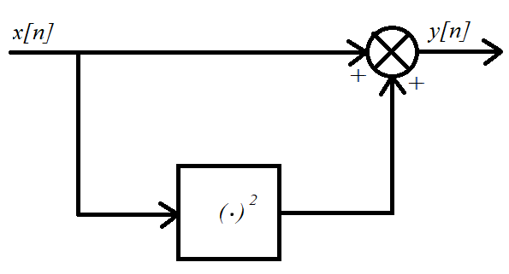

If the input to the system is

$$x\left[n\right]=\cos\left(Ω_{A}n+ϕ_{A}\right)+\cos\left(Ω_{B}n+ϕ_{B}\right),$$

then the output is

$$y\left[n\right]=\frac{1}{2}\cos\left(2Ω_{A}n+2ϕ_{A}\right)+\frac{1}{2}\cos\left(2Ω_{B}n+2ϕ_{B}\right)+\cos\left(\left(Ω_{A}+Ω_{B}\right)n+ϕ_{A}+ϕ_{B}\right)+\cos\left(\left(Ω_{A}-Ω_{B}\right)n+ϕ_{A}-ϕ_{B}\right)+\cos\left(Ω_{A}n+ϕ_{A}\right)+\cos\left(Ω_{B}n+ϕ_{B}\right)+1.$$

This indicates that a quadratically nonlinear system may introduce frequency components at double the input frequencies and at sums/differences of the input frequencies.

|  |  |  |  |
| --- | --- | --- | --- |
| **Input frequencies** | **Input phases** | **Output frequencies** | **Output phases** |
| $$Ω_{A}$$ $$Ω_{B}$$ | $$ϕ_{A}$$ $$ϕ_{B}$$ | $$Ω_{A}$$ $$Ω_{B}$$ $$2Ω_{A}$$ $$2Ω_{B}$$ $$Ω_{A}+Ω_{B}$$ $$Ω_{A}-Ω_{B}$$ $0$ (DC component) | $$ϕ_{A}$$ $$ϕ_{B}$$ $$2ϕ_{A}$$ $$2ϕ_{B}$$ $$ϕ_{A}+ϕ_{B}$$ $$ϕ_{A}-ϕ_{B}$$ |

The bispectrum is

$$\left(Ω_{1},Ω_{2}\right)=Y\left(Ω_{1}\right)Y\left(Ω_{2}\right)Y^{*}\left(Ω_{1}+Ω_{2}\right)$$

where $Y\left(Ω\right)$ is the DTFT of $y\left[n\right]$ and $*$ denotes the complex conjugate. The doubling of the input frequencies can be considered as a special case, when $Ω_{1}=Ω_{2}$. The differencing of the input frequencies can be considered by taking the negative frequency axis (note that this only occurs with real signals which have a symmetrical spectrum).

# Bispectrum and Polyspectra

The power spectrum of $x[n]$ is

$$P\left(Ω\right)=Y\left(Ω\right)Y^{*}\left(Ω\right),$$

which can be used to detect second order correlations, but is blind to higher order correlations. The bispectrum of $x[n]$ is defined as

$$Y\left(Ω_{1},Ω_{2}\right)=Y\left(Ω_{1}\right)Y\left(Ω_{2}\right)Y^{*}\left(Ω_{1}+Ω_{2}\right),$$

which can be used to detect third order correlations (quadratic nonlinearity). In general, the $N$-th order polyspectrum is

$$N\left(Ω_{1},Ω_{2},…,Ω_{N}\right)=Y^{*}\left(\sum_{n=1}^{N}{Ω_{n}}\right)∙\prod_{n=1}^{N}{Y(Ω_{n})},$$

which can be used to detect $(N+1)$-th order correlations.

# Magnitude Response

For a ‘large’ magnitude, we require $\left|Y\left(Ω_{1}\right)\right|$, $\left|Y\left(Ω_{2}\right)\right|$ and $\left|Y\left(Ω_{1}+Ω_{2}\right)\right|$ to all be large. If a signal happens to have significant frequency components at $\left(Ω_{1},Ω_{2}\right)=\left(Ω_{A},Ω_{B}\right)$ and is the output of a quadratically nonlinear system, then it is expected that a significant component will also be introduced at $Ω_{A}+Ω_{B}$, causing a peak in the bispectrum at $\left(Ω_{A},Ω_{B}\right)$.

# Phase Response

The phase of $B(Ω_{1},Ω_{2}$) is

$$\arg{B(Ω_{1},Ω_{2})}=\arg{Y(Ω_{1})}+\arg{Y(Ω_{2})}-\arg{Y\left(Ω_{1}+Ω_{2}\right)}.$$

Due to QPC, peaks in the bispectrum introduced due to quadratic nonlinearity will also have zero phase.

# Arbitrarily Nonlinear Systems

For an arbitrary nonlinear system, $y\left[n\right]=S\left\{x\left[n\right]\right\},$ the system function can be decomposed via a Taylor series,

$$S\left\{x\left[n\right]\right\}=\sum_{k=0}^{∞}{\frac{S^{\left(n\right)}\left\{a\right\}}{k!}{\left(x[n]-a\right)}^{k}}.$$

Disregarding the higher order terms,

$$S\left\{x\left[n\right]\right\}≈S\left\{a\right\}+S^{'}\left\{a\right\}\left(x\left[n\right]-a\right)+\frac{1}{2}S^{''}\left\{a\right\}{\left(x\left[n\right]-a\right)}^{2}.$$

This is the form of a quadratically nonlinear system, thus we expect some QPC (and also higher order correlations) in an arbitrary nonlinear speech production system.

# Bicoherence

The bicoherence is the normalised bispectrum

$$B_{c}\left(Ω_{1},Ω_{2}\right)=\frac{B\left(Ω_{1},Ω_{2}\right)-\min\left|B\right|}{\max\left|B\right|-\min\left|B\right|}.$$

When calculating the bicoherence for a long speech signal, it can be approximated by chunking and windowing the signal, calculating the bicoherence of each windowed segment and averaging.

# MATLAB Implementation

clear;

addpath('..\Speech samples');

% Specify constants

N = 1024; % No. samples

M = N/2;

n = -M:M-1;

f = n/N;

B_bins = 128; % No. bins for bispectrum plot

B_bin_size = N/B_bins;

% Quadratically nonlinear system

f1 = 0.1;

f2 = 0.15;

x = exp(2j*pi*f1*n)+exp(2j*pi*f2*n);

y = x.^2 + x;

% Audio read

x = zeros(1,N);

y = 5*audioread('synthetic_vowel.wav');

%y = 5*6*audioread('vowel.wav');

y = y(1:N);

x = zeros(N,1);

% FFTs

X = 1/sqrt(N)*fft(x);

Y = 1/sqrt(N)*fft(y);

% Bispectrum calculation

for k=1:N

for m=1:N

if k+m<=N

B(k,m) = Y(k)*Y(m)*conj(Y(k+m));

else

B(k,m) = Y(k)*Y(m)*conj(Y(k+m-N));

end

end

end

% Make spectrum symmetrical around zero

X = fftshift(X);

Y = fftshift(Y);

B = fftshift(B);

% Bin the bispectrum, so that it is easier to see

B_small = zeros(B_bins);

B_small = reshape(B,B_bin_size,B_bins,B_bin_size,B_bins,1);

B_small = sum(B_small,[1 3]);

B_small = reshape(B_small,B_bins,B_bins,1);

ticks = linspace(1.5, B_bins-0.5, 11);

ticklabels = {'-0.5' '-0.4' '-0.3' '-0.2' '-0.1' '0' '0.1' '0.2' '0.3' '0.4' '0.5'};

% Plot input and output spectrum

figure(1)

subplot(2,1,1)

plot(f,abs(X))

title('Input magnitude response')

xlabel('f (normalised)')

ylabel('X[f]')

subplot(2,1,2)

plot(f,abs(Y))

title('Output magnitude response')

xlabel('f (normalised)')

ylabel('Y[f]')

% Surf plot of bispectrum magnitude

figure(2)

surf(abs(B_small))

title('Bispectrum magnitude')

xlabel('f1 (normalised)')

ylabel('f2 (normalised)')

zlabel('|B[f1,f2]|')

xticks(ticks)

xticklabels(ticklabels)

yticks(ticks)

yticklabels(ticklabels)

% Contour plot of bispectrum

figure(3)

contour(abs(B_small))

title('Bispectrum magnitude')

xlabel('f1 (normalised)')

ylabel('f2 (normalised)')

zlabel('|B[f1,f2]|')

xticks(ticks)

xticklabels(ticklabels)

yticks(ticks)

yticklabels(ticklabels)

% Surf plot of bispectrum phase

figure(4)

contour(angle(B_small))

title('Bispectrum phase')

xlabel('f1 (normalised)')

ylabel('f2 (normalised)')

zlabel('|B[f1,f2]|')

xticks(ticks)

xticklabels(ticklabels)

yticks(ticks)

yticklabels(ticklabels)

# Single Complex Exponential

Here, the bispectrum is calculated for a single complex exponential $x\left[n\right]=e^{j2πf_{1}n}$ where the normalised frequency is set to $f_{1}=0.1$. The peaks in the bispectrum magnitude are around 18.

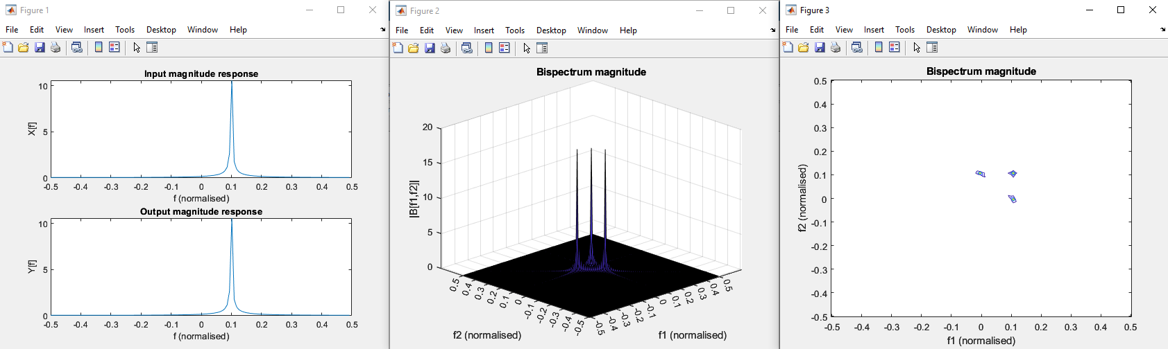

# Quadratically Nonlinear System with Single Complex Exponential Input

Now, feed the complex exponential $x\left[n\right]=e^{j2πf_{1}n}$ through the system $y\left[n\right]=x^{2}\left[n\right]+x\left[n\right]$. The output is

|  |  |
| --- | --- |
| $$y\left[n\right]=e^{j2π(2f_{1})n}+e^{j2πf_{1}n},$$ | (8.10) |

so there are frequency components at $f_{1}=0.1$ and $2f_{1}=0.2$. Nonlinearity should be detected at $B\left(0.1, 0.1\right).$ Now, calculate the bispectrum of $y[n]$.

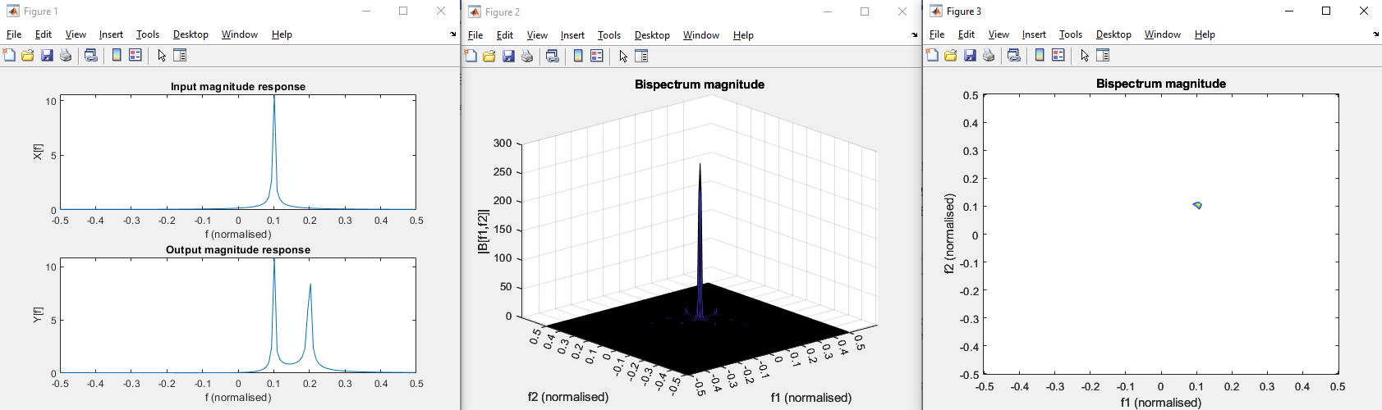

There is significant bispectrum magnitude at $B(0.1, 0.1)$ indicating high correlation between $f=0.1$ and $f=0.2$ as expected. The biphase appears to be zero at the peak – check this.

Updated Notes

The bispectrum is a tool used in higher-order statistics for detecting nonlinearities in systems, defined as the two dimensional Fourier transform of the third order cumulant,

$$B\left(f_{1},f_{2}\right)=\sum_{m_{1}}^{ }{\sum_{m_{2}}^{ }{c_{3X}\left[m_{1},m_{2}\right]e^{j2π\left(f_{1}m_{1}+f_{2}m_{2}\right)}}},$$

where the third order cumulant is defined as

$$c_{3X}\left[m_{1},m_{2}\right]=E\left[x\left[n\right]x\left[n+m_{1}\right]x[n+m_{2}]\right].$$